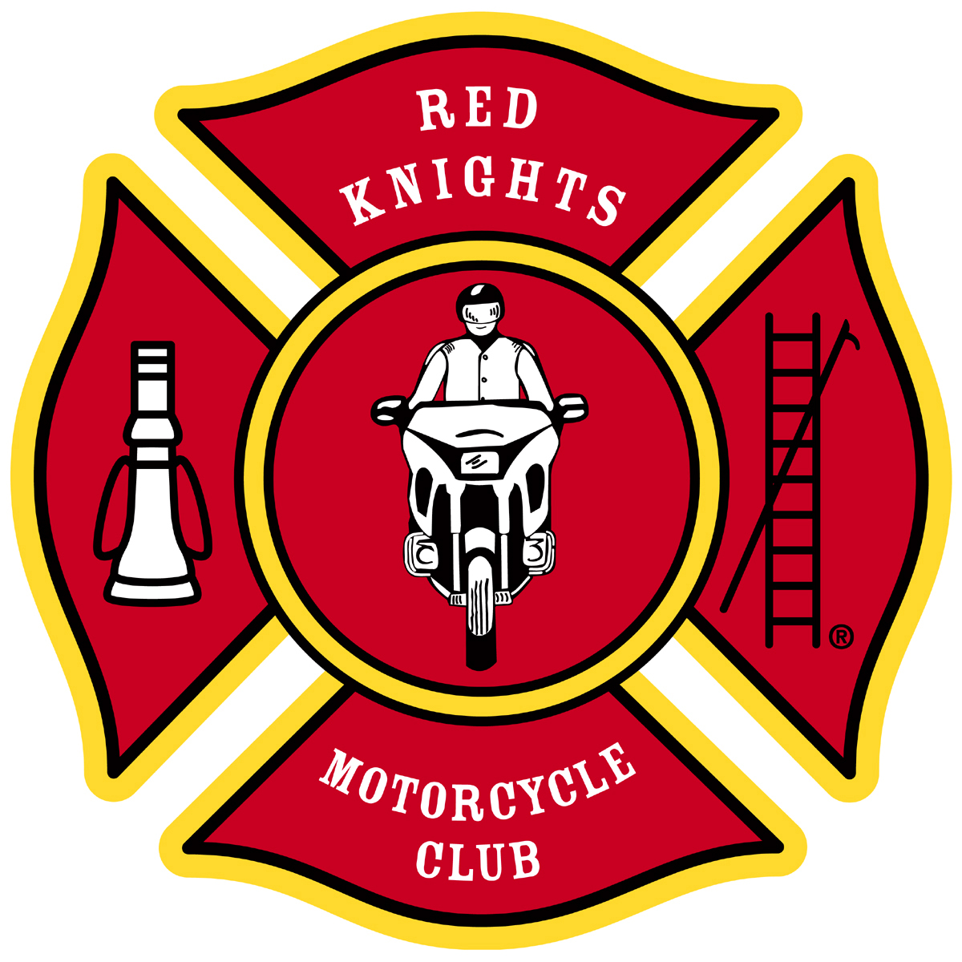
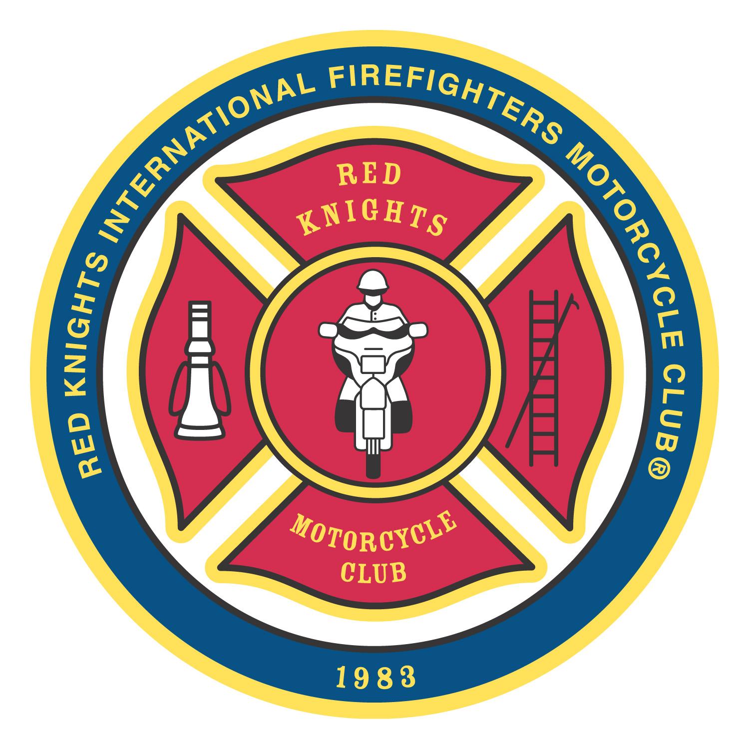
®
Red Knights International Firefighters Motorcycle Club® Inc.
Office of the Region 2 Director
Leo J. Patry
1176 Andersen Drive
Kingston, Ontario, Canada, K7P 3H8
1-613-766-2271
region2@redknightsmc.com

Report from Region 2

I never realized when I joined the Red Knights 33 years ago what a major affect it would have on my life. I have been fortunate to have been able to work with, and to learn from, the great members that have contributed to our growth and success both in the past and the present.

I look forward to the many new exciting things to come with our continued growth around the world.

The year 2023 will bring our first International Convention to be held outside of North America with the convention being held in Fussach Austria September 7 – 10 2023

I am so looking forward to this Convention as are a lot of our members who will also be attending from the USA and Canada to have the opportunity to meet and make new friends with our brothers and sisters in the European chapters.

The past years activities of the Red Knights Chapters in Region 2 have been slowly come back up to previous years levels, two years of Covid really played havoc with the activities of both the International and the chapters.

The Ontario and Atlantic Associations of the Red Knights in Region 2 have both continued to grow and become more active providing many more opportunities for the membership to have designations and events to ride to and the ability to meet other Red Knights and form new and lasting friendships.

Each year the list of Chapters and Associations holding rallies and events grows and I strongly encourage you, the chapters, and individuals to try and encompass these events in your road trips.

As the Region 2 Director I have attempted to maintain contact with all chapters in the Region, informing them of events and notices from the International and other Associations within the Region and helping them with the development of their chapters, encouraging all the chapters and MALs to contact me with any questions or problems they may be experiencing within the Red Knights Organization.

I have continued to maintain a time log of time spent as the Regional Director along with updating the Procedures manual for the Position of Region 2 director.

To date this year, I have averaged 6 Hours per week working on emails, calls to chapters and Associations along with the generation of reports to the International Board.
That time frame doesn’t include the time utilized in the attending of Board meetings of both the International and the regions Associations.

I have attended all Executive meetings of the international board including several Zoom meetings.

I also attended all Ontario Association Meetings both in person and by means of Zoom meetings.

I was fortunate to be able to attend the Atlantic Association rally in Ducks Pond New Brunswick July 14-17, 2022, and participate in a number of events, and meetings.

- The Annual Yankee Rally in Plattsburg New York
- Spent three days at the Red Knights memorial house and got to visit with some of our founding fathers.
- The Red Knights ride in Lake George hosted by New York 3
- The Red Knights Americade Open House and BBQ at the Lake George Fire Hall hosted by New York 12.
- The International Convention in Johnstown Pennsylvania
- The Ontario Association meet and greet held in Smith Falls Ontario

I was also honored in being able to represent the Red Knights International at the Funerals of two Region 2 members that passed in 2022.

Sincerely yours in brotherhood
Leo Patry
Region 2 Director

